UNITED STATES
SECURITIES AND EXCHANGE COMMISSION
WASHINGTON, D.C. 20549

FORM 8-K
CURRENT REPORT
Pursuant to Section 13 or 15(d) of the
Securities Exchange Act of 1934
Date of report (Date of earliest event reported): July 6, 2026

 |  |  | Versant Media Group, Inc.
(Exact Name of Registrant
as Specified in its Charter)
Pennsylvania |  |  | 001-42856 |  |  | 39-2087186
(State or Other Jurisdiction of Incorporation) |  |  | (Commission File Number) |  |  | (IRS Employer Identification No.)
229 West 43rd Street
New York, NY |  |  |  |  |  | 10036
(Address of Principal Executive Offices) |  |  |  |  |  | (Zip Code)

Registrant’s telephone number, including area code: (646) 832-1000
(Former name or former address, if changed since last report)

Check the appropriate box below if the Form 8-K filing is intended to simultaneously satisfy the filing obligation of the registrant under any of the following provisions:
☐ Written communications pursuant to Rule 425 under the Securities Act (17 CFR 230.425)
☐ Soliciting material pursuant to Rule 14a-12 under the Exchange Act (17 CFR 240.14a-12)
☐ Pre-commencement communications pursuant to Rule 14d-2(b) under the Exchange Act (17 CFR 240.14d-2(b))
☐ Pre-commencement communications pursuant to Rule 13e-4(c) under the Exchange Act (17 CFR 240.13e-4(c))
Securities registered pursuant to Section 12(b) of the Act:
Title of each class |  |  | Trading Symbol(s) |  |  | Name of each exchange on which registered
Class A Common Stock, $0.01 par value |  |  | VSNT |  |  | The Nasdaq Stock Market LLC
Indicate by check mark whether the registrant is an emerging growth company as defined in Rule 405 of the Securities Act of 1933 (§230.405 of this chapter) or Rule 12b-2 of the Securities Exchange Act of 1934 (§240.12b-2 of this chapter).
Emerging growth company ☐
If an emerging growth company, indicate by check mark if the registrant has elected not to use the extended transition period for complying with any new or revised financial accounting standards provided pursuant to Section 13(a) of the Exchange Act. ☐

Item 7.01. Regulation FD Disclosure.

On July 6, 2026, Versant Media Group, Inc. (“Versant”) issued a press release announcing that it entered into a stock purchase agreement with Full Swing Golf Holdings, Inc., a Delaware corporation (the “Company”) and FSG MidCo, LLC, a Delaware limited liability company (the “Seller”), pursuant to which, among other things, the Company agreed to acquire all of the equity interests of the Company from the Seller for an aggregate purchase price of $530,000,000, subject to customary adjustments (the “Transaction”).

The Transaction is expected to close in the second half of 2026, subject to the satisfaction or waiver of customary closing conditions. A copy of the press release is attached as Exhibit 99.1 to this Current Report on Form 8-K and is incorporated herein by reference.

The information being furnished pursuant Item 7.01 of this Current Report on Form 8-K, including Exhibit 99.1, shall not be deemed to be “filed” for purposes of Section 18 of the Securities Exchange Act of 1934, as amended (the “Exchange Act”), or otherwise be subject to the liability of that section, and shall not be incorporated by reference into any other document filed under the Securities Act of 1933, as amended, or the Exchange Act, except as shall be expressly set forth by specific reference in such filing.

Caution Concerning Forward-Looking Statements

This Current Report on Form 8-K includes statements that may constitute forward-looking statements within the meaning of the Private Securities Litigation Reform Act of 1995, Section 27A of the Securities Act of 1933, and Section 21E of the Securities Exchange Act of 1934. In some cases, you can identify these statements by forward-looking words such as “may,” “might,” “would,” “will,” “should,” “could,” “expects,” “plans,” “intends,” “anticipates,” “believes,” “estimates,” “predicts,” “potential,” “opportunity,” “strategy,” “future,” “goal,” “commit,” or “continue,” the negative of these terms and other comparable terminology. These statements are only predictions based on our current expectations and projections about future events and reflect our beliefs regarding such future events and do not represent historical facts or statements of current condition. In evaluating these statements, readers should consider various factors, including the risks and uncertainties we describe in the “Risk Factors” sections of our most recent Annual Report on Form 10-K, and other reports filed with the Securities and Exchange Commission (SEC). Factors that could cause our actual results to differ materially from these forward-looking statements include changes in and/or risks associated with: the Company’s ability to complete strategic transactions, such as the Transaction, including the satisfaction of conditions to closing and the timing of anticipated closing, and to recognize anticipated benefits of the Transaction; the competitive environment; consumer behavior; distribution agreements; the advertising market; our brands and reputation; consumer acceptance of our content; growth of our digital platforms; use and protection of our intellectual property; cyber-attacks or incidents, information or security breaches or technology disruptions; weak economic conditions; personnel; labor disputes; laws and regulations; network rebrands; adverse decisions in litigation or governmental investigations; investments and acquisitions; our separation from Comcast Corporation; obligations associated with being a public company; our indebtedness; and other risks described from time to time in reports and other documents we file with the SEC. Readers are cautioned not to place undue reliance on forward-looking statements, which speak only as of the date they are made, and involve risks and uncertainties that could cause actual events or our actual results to differ materially from those expressed in any such forward-looking statements. We undertake no obligation to update or revise publicly any forward-looking statements, whether because of new information, future events or otherwise. The amount and timing of any dividends and share repurchases are subject to business, economic and other relevant factors.

Item 9.01. Financial Statements and Exhibits.
Exhibit Number |  |  | Description
99.1 |  |  | Press Release dated July 6, 2026
104 |  |  | Cover Page Interactive Data File (embedded within the Inline XBRL document)

SIGNATURES

Pursuant to the requirements of the Securities Exchange Act of 1934, the registrant has duly caused this report to be signed on its behalf by the undersigned hereunto duly authorized.

 |  |  |  |  |  | VERSANT MEDIA GROUP, INC
Date: |  |  | July 6, 2026 |  |  | By: |  |  | /s/ Jordan R. Fasbender
 |  |  |  |  |  | Name: |  |  | Jordan R. Fasbender
 |  |  |  |  |  | Title: |  |  | General Counsel and Corporate Secretary

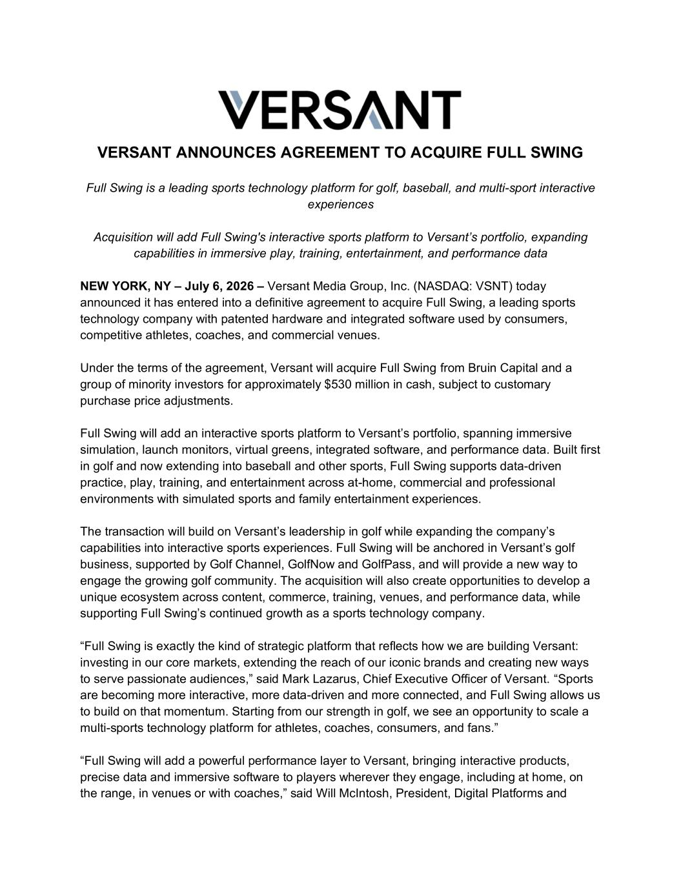

VERSANT ANNOUNCES AGREEMENT TO ACQUIRE FULL SWING Full Swing is a leading sports technology platform for golf, baseball, and multi-sport interactive experiences Acquisition will add Full Swing's interactive sports platform to Versant’s portfolio, expanding capabilities in immersive play, training, entertainment, and performance data NEW YORK, NY – July 6, 2026 – Versant Media Group, Inc. (NASDAQ: VSNT) today announced it has entered into a definitive agreement to acquire Full Swing, a leading sports technology company with patented hardware and integrated software used by consumers, competitive athletes, coaches, and commercial venues. Under the terms of the agreement, Versant will acquire Full Swing from Bruin Capital and a group of minority investors for approximately $530 million in cash, subject to customary purchase price adjustments. Full Swing will add an interactive sports platform to Versant’s portfolio, spanning immersive simulation, launch monitors, virtual greens, integrated software, and performance data. Built first in golf and now extending into baseball and other sports, Full Swing supports data-driven practice, play, training, and entertainment across at-home, commercial and professional environments with simulated sports and family entertainment experiences. The transaction will build on Versant’s leadership in golf while expanding the company’s capabilities into interactive sports experiences. Full Swing will be anchored in Versant’s golf business, supported by Golf Channel, GolfNow and GolfPass, and will provide a new way to engage the growing golf community. The acquisition will also create opportunities to develop a unique ecosystem across content, commerce, training, venues, and performance data, while supporting Full Swing’s continued growth as a sports technology company. “Full Swing is exactly the kind of strategic platform that reflects how we are building Versant: investing in our core markets, extending the reach of our iconic brands and creating new ways to serve passionate audiences,” said Mark Lazarus, Chief Executive Officer of Versant. “Sports are becoming more interactive, more data-driven and more connected, and Full Swing allows us to build on that momentum. Starting from our strength in golf, we see an opportunity to scale a multi-sports technology platform for athletes, coaches, consumers, and fans.” “Full Swing will add a powerful performance layer to Versant, bringing interactive products, precise data and immersive software to players wherever they engage, including at home, on the range, in venues or with coaches,” said Will McIntosh, President, Digital Platforms and

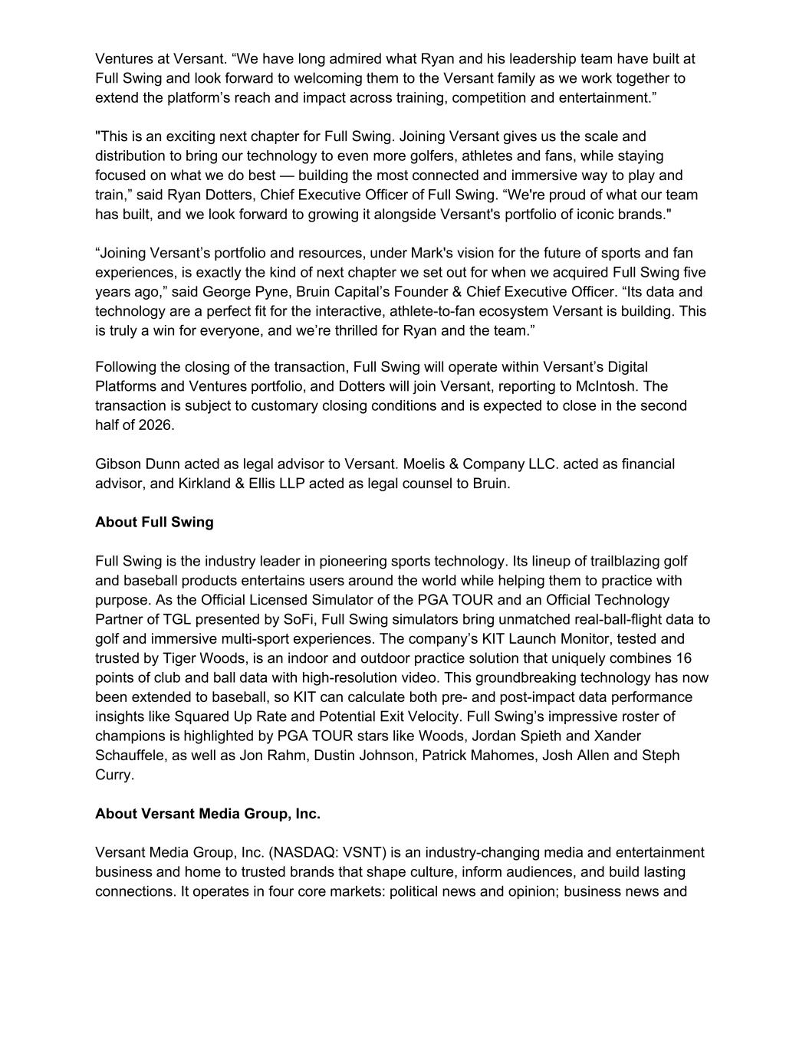
Ventures at Versant. “We have long admired what Ryan and his leadership team have built at Full Swing and look forward to welcoming them to the Versant family as we work together to extend the platform’s reach and impact across training, competition and entertainment.” "This is an exciting next chapter for Full Swing. Joining Versant gives us the scale and distribution to bring our technology to even more golfers, athletes and fans, while staying focused on what we do best — building the most connected and immersive way to play and train,” said Ryan Dotters, Chief Executive Officer of Full Swing. “We're proud of what our team has built, and we look forward to growing it alongside Versant's portfolio of iconic brands." “Joining Versant’s portfolio and resources, under Mark's vision for the future of sports and fan experiences, is exactly the kind of next chapter we set out for when we acquired Full Swing five years ago,” said George Pyne, Bruin Capital’s Founder & Chief Executive Officer. “Its data and technology are a perfect fit for the interactive, athlete-to-fan ecosystem Versant is building. This is truly a win for everyone, and we’re thrilled for Ryan and the team.” Following the closing of the transaction, Full Swing will operate within Versant’s Digital Platforms and Ventures portfolio, and Dotters will join Versant, reporting to McIntosh. The transaction is subject to customary closing conditions and is expected to close in the second half of 2026. Gibson Dunn acted as legal advisor to Versant. Moelis & Company LLC. acted as financial advisor, and Kirkland & Ellis LLP acted as legal counsel to Bruin. About Full Swing Full Swing is the industry leader in pioneering sports technology. Its lineup of trailblazing golf and baseball products entertains users around the world while helping them to practice with purpose. As the Official Licensed Simulator of the PGA TOUR and an Official Technology Partner of TGL presented by SoFi, Full Swing simulators bring unmatched real-ball-flight data to golf and immersive multi-sport experiences. The company’s KIT Launch Monitor, tested and trusted by Tiger Woods, is an indoor and outdoor practice solution that uniquely combines 16 points of club and ball data with high-resolution video. This groundbreaking technology has now been extended to baseball, so KIT can calculate both pre- and post-impact data performance insights like Squared Up Rate and Potential Exit Velocity. Full Swing’s impressive roster of champions is highlighted by PGA TOUR stars like Woods, Jordan Spieth and Xander Schauffele, as well as Jon Rahm, Dustin Johnson, Patrick Mahomes, Josh Allen and Steph Curry. About Versant Media Group, Inc. Versant Media Group, Inc. (NASDAQ: VSNT) is an industry-changing media and entertainment business and home to trusted brands that shape culture, inform audiences, and build lasting connections. It operates in four core markets: political news and opinion; business news and

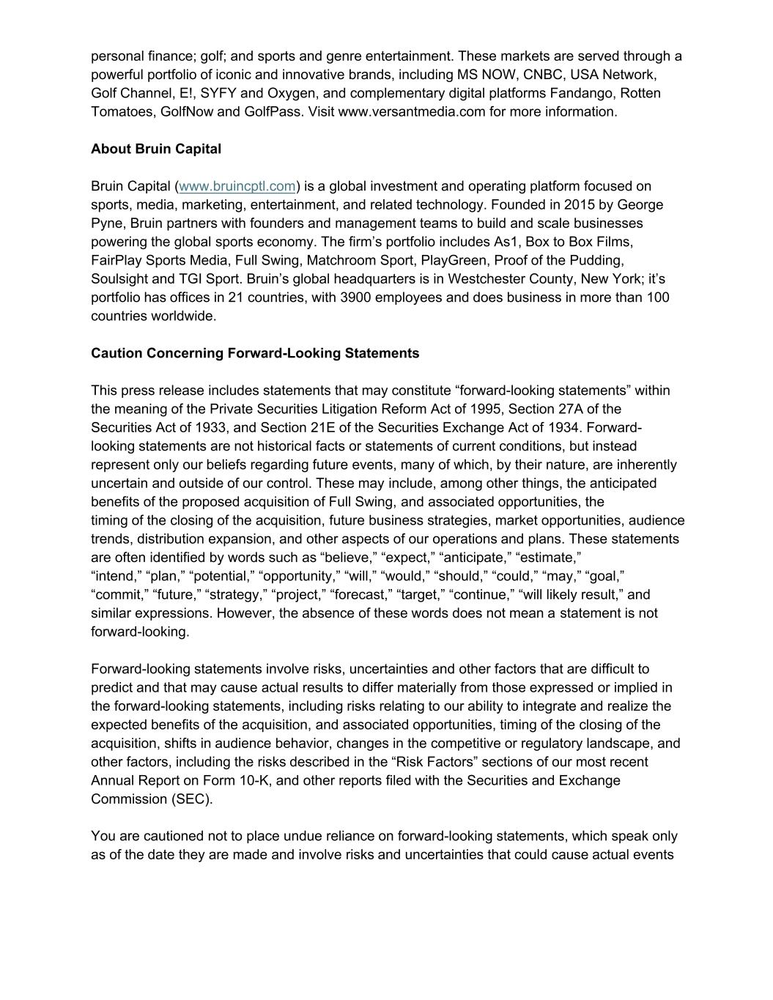
personal finance; golf; and sports and genre entertainment. These markets are served through a powerful portfolio of iconic and innovative brands, including MS NOW, CNBC, USA Network, Golf Channel, E!, SYFY and Oxygen, and complementary digital platforms Fandango, Rotten Tomatoes, GolfNow and GolfPass. Visit www.versantmedia.com for more information. About Bruin Capital Bruin Capital (www.bruincptl.com) is a global investment and operating platform focused on sports, media, marketing, entertainment, and related technology. Founded in 2015 by George Pyne, Bruin partners with founders and management teams to build and scale businesses powering the global sports economy. The firm’s portfolio includes As1, Box to Box Films, FairPlay Sports Media, Full Swing, Matchroom Sport, PlayGreen, Proof of the Pudding, Soulsight and TGI Sport. Bruin’s global headquarters is in Westchester County, New York; it’s portfolio has offices in 21 countries, with 3900 employees and does business in more than 100 countries worldwide. Caution Concerning Forward-Looking Statements This press release includes statements that may constitute “forward-looking statements” within the meaning of the Private Securities Litigation Reform Act of 1995, Section 27A of the Securities Act of 1933, and Section 21E of the Securities Exchange Act of 1934. Forward- looking statements are not historical facts or statements of current conditions, but instead represent only our beliefs regarding future events, many of which, by their nature, are inherently uncertain and outside of our control. These may include, among other things, the anticipated benefits of the proposed acquisition of Full Swing, and associated opportunities, the timing of the closing of the acquisition, future business strategies, market opportunities, audience trends, distribution expansion, and other aspects of our operations and plans. These statements are often identified by words such as “believe,” “expect,” “anticipate,” “estimate,” “intend,” “plan,” “potential,” “opportunity,” “will,” “would,” “should,” “could,” “may,” “goal,” “commit,” “future,” “strategy,” “project,” “forecast,” “target,” “continue,” “will likely result,” and similar expressions. However, the absence of these words does not mean a statement is not forward-looking. Forward-looking statements involve risks, uncertainties and other factors that are difficult to predict and that may cause actual results to differ materially from those expressed or implied in the forward-looking statements, including risks relating to our ability to integrate and realize the expected benefits of the acquisition, and associated opportunities, timing of the closing of the acquisition, shifts in audience behavior, changes in the competitive or regulatory landscape, and other factors, including the risks described in the “Risk Factors” sections of our most recent Annual Report on Form 10-K, and other reports filed with the Securities and Exchange Commission (SEC). You are cautioned not to place undue reliance on forward-looking statements, which speak only as of the date they are made and involve risks and uncertainties that could cause actual events

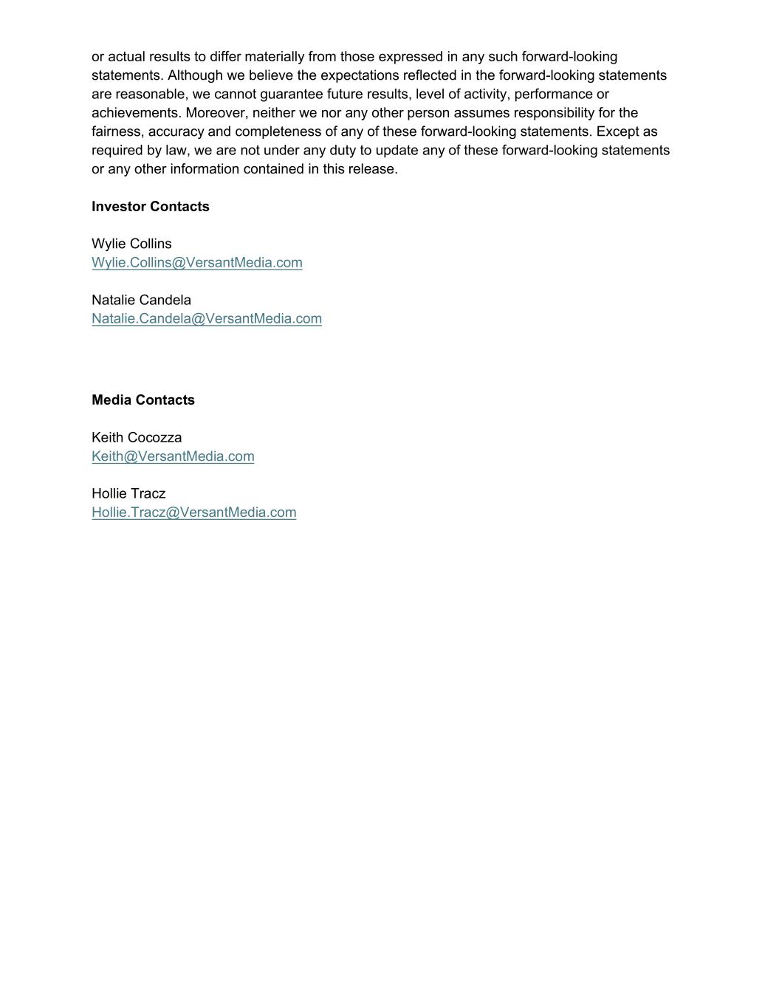
or actual results to differ materially from those expressed in any such forward-looking statements. Although we believe the expectations reflected in the forward-looking statements are reasonable, we cannot guarantee future results, level of activity, performance or achievements. Moreover, neither we nor any other person assumes responsibility for the fairness, accuracy and completeness of any of these forward-looking statements. Except as required by law, we are not under any duty to update any of these forward-looking statements or any other information contained in this release. Investor Contacts Wylie Collins Wylie.Collins@VersantMedia.com Natalie Candela Natalie.Candela@VersantMedia.com Media Contacts Keith Cocozza Keith@VersantMedia.com Hollie Tracz Hollie.Tracz@VersantMedia.com

